Project Planning Phase

Project Planning Template (Product Backlog, Sprint Planning, Stories, Story points)

|  |  |
| --- | --- |
| Date | 02 November 2022 |
| Team ID | PNT2022TMID52096 |
| Project Name | Intelligent Vehicle Damage Assessment and Cost Estimator for Insurance Companies |
| Maximum Marks | 8 Marks |

Product Backlog, Sprint Schedule, and Estimation (4 Marks)

Use the below template to create product backlog and sprint schedule

|  |  |  |  |  |  |  |
| --- | --- | --- | --- | --- | --- | --- |
| Sprint | Functional  Requirement (Epic) | User Story  Number | User Story / Task | Story Points | Priority | Team Members |
| Sprint-1 | Registration, Dashboard | USN-1 | As a user, I can register for the application by entering my email, password, and confirming my password. | 20 | High | P. Muthu Lakshmi (M1) |
| Sprint-2 | Page work, Admin panel | USN-2 | As a user, I will receive confirmation email once I have registered for the application | 20 | High | P. Muthu Lakshmi (Team lead), R. Murugeswari |
| Sprint-3 | Portal, services | USN-3 | As a user, I can register for the application through Facebook | 20 | Low | S. Muthu Lakshmi, lenson(M3) |
| Sprint-4 | Delivery of final code | USN-4 | As a user, I can register for the application through Gmail | 20 | Medium | P. Muthu Lakshmi,R. Murugeswari,S. Muthu Lakshmi |
| Sprint-1 | Login | USN-5 | As a user, I can log into the application by entering email & password | 20 | High | P. Muthu Lakshmi |

Project Tracker, Velocity & Burndown Chart: (4 Marks)

|  |  |  |  |  |  |  |
| --- | --- | --- | --- | --- | --- | --- |
| Sprint | Total Story Points | Duration | Sprint Start Date | Sprint End Date (Planned) | Story Points  Completed (as on  Planned End Date) | Sprint Release Date (Actual) |
| Sprint-1 | 20 | 2 Days | 2 Nov 2022 | 02 Nov 2022 |  | 4 Nov 2022 |
| Sprint-2 | 20 | 2 Days | 4 Nov 2022 | 05 Nov 2022 |  | 6 Nov 2022 |
| Sprint-3 | 20 | 2 Days | 6 Nov 2022 | 12 Nov 2022 |  | 8 Nov 2022 |
| Sprint-4 | 20 | 4 Days | 8 Nov 2022 | 19 Nov 2022 |  | 12 Nov 2022 |

Velocity:

Imagine we have a 10-day sprint duration, and the velocity of the team is 20 (points per sprint). Let’s calculate the team’s average velocity (AV) per iteration unit (story points per day)

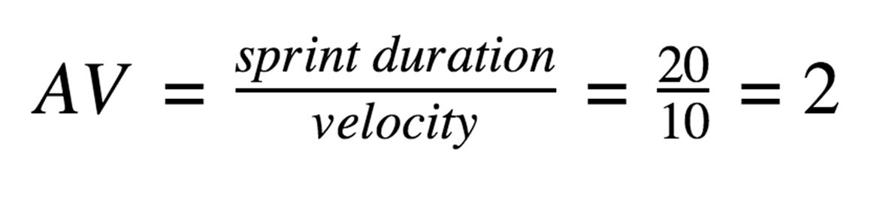

Burndown Chart:

A burn down chart is a graphical representation of work left to do versus time. It is often used in agile software development methodologies such as Scrum. However, burn down charts can be applied to any project containing measurable progress over time.

